**Task 1 Performance Report**

SUT Hardware

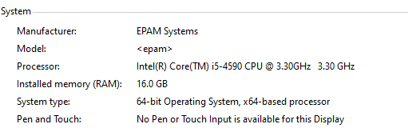

Jmeter Server Hardware

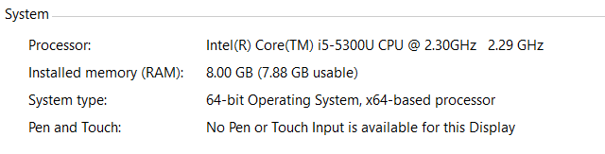

Test Result

Concurrent=10 from View Result Tress there is no error, so the system has been setup to multiply-user correctly.

